This n That

An e-mail newsletter from Agapé Athletics Club

Editor: Marieta Bortoli 082 466 7031 9 April 2018 www.agape.org.za

E-mail: marietabortoli@gmail.com

NB

- Next league race – Morula Half Marathon – 21 April
- Awards function – June
- Agapé race (Jacaranda City Challenge) – 13 October. Members to assist. PLEASE DIARIZE !!!!!!

Editorial

There is no official race in Pretoria this coming Saturday. You can only take part in the Park run or the Cross Country races

Please take note that there are only just over two weeks left should you want a substitution for Comrades. Substitution closes on 25 April. There are currently two numbers up for grabs. Please refer to “In the mailbox” for more details

Notice Board Additions

◊ City of Tshwane Half Marathon
◊

Attachments

□ 2018 Cross Country fixture list

Birthday Greetings

May God look down and bless you now when your birthday’s here and keep you in His loving care each day throughout the year, and may He grant you happiness in everything you do – today, tomorrow, always, every day your whole life through!

Annelie Prinsloo 09 April | Kenny van der Merwe 14 April
Jonathan Nash 15 April | Jacques Benadie 21 April
Erika Fourie 24 April | Elmirie Meyer 27 April
Anlie Dicks 28 April | Maria van Zyl 28 April
Willie Struwig 30 April

Personalia

Welcome new and former members

Keziah Morrison Setrichia Morrison (social member)

Congratulations

Congratulations to the following members:

Ford 3-in-1 race:
Ken Nurden – 10km 1st 80+
Lammie Fourie - 10km 1st 70 - 79
Gina Hughes - 10km 1st 70 - 79
Mandy Atkins - 21.1km 1st 40 - 49
Gustav Bink -21.1km 2nd overall walker

Thank you’s

In the mailbox

Wally Hayward
Ek het reeds ingeskryf vir die Wally 21 maar ek kan nie die wedloop doen nie.
Is daar dalk iemand by Agape wat my inskrywing wil/kan oorneem?
Baie dankie
Maryna Meintjes: Cell: +27 82 386 1131
==

Comrades
Comrades entries available:
- Eddie du Toit 082 803 5379 mredutoit@gmail.com
- Pierre Bortoli 082 466 7031 marietabortoli@gmail.com

General
Clothing available:
Buffs @ R100
Ladies skirts @ R200
Second skins @ R220
Age tags @ R30

Please contact Marietjie if you wish to purchase some of the items:
Cell: 072 541 7268 E-mail: ventermarix9@gmail.com
The items will also be available at races, please visit our gazebo

Race reports/Upcoming race information

Denel League race (24 March 2018)
Separate start for walkers? No (0/5)
Separate start for 10/21? No (0/5)
Prize money for walkers: First three, but no age category prizes. (3/5)
Separate results for walkers: Yes (5/5)
Start: Bit of a push and shovel to get from the terrain to the actual start, but once there, it was nice and wide and filled up from the back. However, there was a 90 degree turn within a few metres from the start, which led to a bit of a bottleneck. Good (4/5)
Route: Quite flat for the greater part, with just two relatively short but steep hills that broke a race walking stride into a power walking stride. There was one stretch where we were walking in an Easterly direction on the right side of the road when the front runners approached us and we had cars mixed up in between, all on one side of the road, and that was a bit scary. With the middleman in place between the two lanes, perhaps the organisers can block off the one side for the runners/walkers in future. We had two doglegs, one right at the start and one from around 19-20km, which allowed you to see who your competitors were and where they were. I did not like the last 150 metres or so on the uneven, wet grass, but there’s not much the organisers can do about that. Very good (4/5)
Marshalling: Excellent (5/5)
Water points: Way too few helpers on each of the water points and many runners had to stop and help themselves. I was involved in a keen race with Hudsy Hudsenberg and just before the water point around 12km he was 18 steps ahead of me. Because of the chaos I decided not to take any water, whereas he stopped to get some. I gained 14 steps on him in the process, which was good for me, but unfair to him. Poor (2/5)
Access and parking: More than ample parking, and under cover at that, but with a single entrance I assume many athletes had a problem getting in. Of course, the solution is to arrive early. Very good (4.5/5)
Personal experience: We again had fantastic weather, and I had a fierce competition with Hudsy from around 8km to 15km, before I managed to slowly pull away, even though it was past 20km before I knew I had beaten him. A PB to boot definitely helped improve my overall experience. Very good (4.5/5)
Total: 32/50 (64%)

Ford 3-in-1 race (7 April 2018)
Separate start for walkers? No (0/5)
Separate start for 10/21? No (0/5)
Prize money for walkers: First two, but no age category prizes. (2/5)
Separate results for walkers: No (0/5)
Start: Just before the start I thought we were confined to the one side of the road, but a few minutes before the start we were granted the whole width of the road, which made it really nice and wide. We also started with a shallow descent, which is always nice at the start. The only concern was that the start was delayed by a few minutes because of athletes that were late, so they lose half a point there. Very good (4.5/5)
Route: Quite flat for the first half and I was comfortably on target for another huge PB when we hit the vicious hills at 11 km. From there up to 18 km was really not a route for walkers. I was walking with Zelda Schultz, one of South Africa’s top lady walkers, and even she could not maintain a legitimate style on the hills. From 18 to 21 is nice downhill and we made up a bit of time there. Even though I lost time from 11 to 18 km, I was still in line for a PB at 20km, but then I walked 7:57 for the last part – which was significantly longer than 1.1km. In fact, we had about 80 metres on tar after the 21km mark (which was placed right next to the paint mark on the road, leading me to think that it was placed correctly), followed by nearly 300 metres on grass. The too long route means that I missed my PB by a few seconds, which left a rather bad taste. How can organisers not get the route right? Poor (2/5)
Marshalling: Generally very good, with a few that specifically supported us as walkers (and indicated to Zelda that she was the first lady walker and to me that I was the second male walker), but there were a number of crossings without any marshals (at least not on major crossings), which cost them half a point. Very good (4.5/5)
Water points: The water points were quite good, with enough people and enough and cold water and Coke, but nothing in the sense of the spirit of the Kollonade race. Very good (4.5/5)
Access and parking: More than enough parking, with keen parking attendants. Very good (4.5/5)
Personal experience: Other than the fact that the too long course (or incorrectly placed distance markers?) cost me a PB that left a bad taste, I had a wonderful race, walking around 15.5 km with Zelda (she dropped me at around 19.5km and try as I might, I could not catch her again, eventually finishing around 25 metres behind her). I learned quite a bit from walking with her, which I am sure will help me become a better walker. And for somebody who has won an SA championship, it was lovely to experience how down to earth she was and how prepared to impart knowledge. Very good (4.5/5)
Total: 27.5/50 (55%)

Race Results
Lynnridge Mall Family Day (AGN) 11km race - 2018-04-02
Position | Initials | Surname | Sex | Age | Finish Time
82 | T | De Beer | M | 46 | 01:01:47
103 | L | Fourie | M | 73 | 01:03:59
148 | J | Nordengen | M | 18 | 01:07:15
176 | M | Lange | M | 36 | 01:08:34
252 | M | Boesemberg | F | 61 | 01:12:14
253 | K | Nurden | M | 83 | 01:12:16
395 | A | Potgieter | F | 46 | 01:19:13
419 | V | Vermaak | F | 37 | 01:20:56
482 | D | Frost | M | 61 | 01:24:42
659 | L | Clarke | M | 74 | 01:35:29
829 | E | Loubser | M | 61 | 02:02:49
Lynnridge Mall Family Day (AGN) 22km race - 2018-04-02
Position | Initials | Surname | Sex | Age | Finish Time
40 | K | Imrie | M | 46 | 01:50:45
71 | J | Van Der Merwe | M | 48 | 01:58:42
87 | K | Booyse | F | 35 | 02:00:34
90 | F | Schunke | M | 60 | 02:01:27
97 | P | Kennedy | M | 41 | 02:03:04
119 | W | Reinecke | M | 43 | 02:06:30
262 | A | Strydom | M | 37 | 02:24:57
266 | W | Weder | M | 69 | 02:25:21
283 | G | Vermaak | M | 37 | 02:27:20
303 | W | Focaraccio | F | 35 | 02:29:23
342 | T | Oelofse | F | 43 | 02:33:58
393 | A | Te Reh | M | 68 | 02:42:34
424 | C | Mouton | F | 61 | 02:46:57
443 | L | Gorenewald | F | 48 | 02:51:40

League results

Standings after the Denel race. Our members still do not feature in the top twenty of the Super League. Our ladies moved up from in the forties to 22nd place but our males dropped down to 50th place.

Running
 | Wonderpark Akasia | Denel | Div 1 | Points
FEB | Pos | Pos | Club | League
111 | 1 | 1 | VTM | 40
206 | 2 | 2 | PMMC | 38
69 | 5 | 3 | OVERKRUIN | 34
128 | 4 | 4 | ACE | 33
230 | 7 | 5 | PPMK | 25
180 | 6 | 6 | RESBANK | 24
325 | 3 | 6 | MAGNOLIA | 24
157 | 10 | 8 | AGAPE | 23
90 | 8 | 8 | HQH | 23
515 | 16 | 10 | IRENE | 22
231 | 14 | 11 | RWFL | 21
100 | 15 | 12 | AURECON | 20
35 | 17 | 13 | PVR | 19
115 | 9 | 14 | AFFIES | 17
61 | 12 | 15 | PMWC | 16
170 | 11 | 16 | CSIR | 14
35 | 20 | 17 | ARETE | 9
35 | 13 | 17 | BMW | 9
150 | 18 | 19 | LOVE RUNNING | 6
35 | 19 | 20 | NPO | 4

Walking
Wonderpark Akasia | Denel | + | Points
Pos | Pos | Club | L'gue
1 | 1 | RWFL | 40
2 | 2 | PMWC | 38
2 | 3 | IRENE | 37
4 | 4 | RWFL B | 34
8 | 5 | VTM | 29
11 | 6 | AGAPE | 25
5 | 7 | PMWC B | 23
12 | 8 | SOLIDARITEIT | 22
9 | 9 | ACRW | 21
14 | 9 | PPMK | 21
10 | 11 | BODYWALK | 19
16 | 12 | AFFIES | 17
15 | 12 | PHOBIANS | 17
6 | 14 | LOVE RUNNING | 15
17 | 15 | MAGNOLIA | 14
7 | 15 | GNMA | 14
12 | 17 | TUKS | 9
18 |  | AURECON | 0
18 |  | CORR SERV | 0
18 |  | TRANSNET | 0

Training/Health snippets

Race-day sugar rules
If you skip sugar in longer events, you won’t perform at your best. To maximise sugar’s performance benefits, follow these race-day rules:

- Consume sugar in races lasting longer than one hour
Studies show that sugar boosts performance in events lasting as little as 60 minutes, even though such events aren’t long enough to deplete your carb stores. It appears that sugar does this by stimulating the nervous system
- Take in even more in longer races
In very long events, your performance is limited by the depletion of carbs in the liver and muscles. While 30 – 60g of sugar or other fast-acting carbs will maximise performance in shorter races, runners can gain further performance benefits from taking in as much as 90g per hour in longer races
- Consume multiple types of sugar
It’s impossible to get 90g of carbs per hour from a sports drink. It’s too much fluid. So, in longer events, combine sports drinks and a more concentrated source, such as energy gels

It is also hard for the body to absorb 90g of a single type of carb in one hour. You need to consume a sugar such as glucose or fast acting carb such as maltodextrin in combination with fructose, in approximately a 2:1 ratio. The body processes fructose through a different metabolic channel to other sugars; so, by combining multiple sugars, you absorb sugar through two channels simultaneously
- Train your nutrition
According to Jeukendrup, one of the reasons GI problems are common in races is that runners try to take in a lot more fluid and carbs during events than they do in training. “The gut is adaptable,” he says. Get used to taking in nutrition in long workouts, and you’ll have a much lower risk of running into trouble on race day

Your thought for the week

We are not given a good life or a bad life. We are given a life! It’s up to us to make it good or bad!!

Your smile for the week

There were two buddies, one with a Doberman Pinscher and the other with a Chihuahua. The guy with the Doberman Pinscher says to his friend, "Let's go over to that restaurant and get something to eat."
The guy with the Chihuahua says, "We can't go in there. We've got dogs with us."
The buddy with the Doberman Pinscher says, "Just follow my lead." They walk over to the restaurant, the guy with the Doberman Pinscher puts on a pair of dark glasses and he starts to walk in. The bouncer at the door says, "Sorry, mac, no pets allowed."
The man with the Doberman Pinscher says, "You don't understand. This is my seeing-eye-dog."
The bouncer says, "A Doberman Pinscher?"
He answers, "Yes, they're using them now; they're very good and protect me from robbers, too."
The man at the door says, "Come on in."
The buddy with the Chihuahua figures, "What the heck," so he puts on a pair of dark glasses and starts to walk in.
Once again the bouncer says, "Sorry, pal, no pets allowed."
The guy with the Chihuahua says, "You don't understand. This is my seeing-eye dog."
The bouncer at the door says, "A Chihuahua?"
The man with the Chihuahua says, "A Chihuahua?????? They gave me a Chihuahua?!"

Something to ponder over / something spiritual

Daar word vertel dat die duiwel op 'n keer bankrot gespeel het en dat hy al sy gereedskap sou verkoop aan enigeen wat bereid was om die regte prys te betaal
Op die aand van die vendusie was al die gereedskap pragtig uitgestal en het die hele bose lot daar gelê: Daar was jaloesie, afguns, haat, onsedelikheid, owerspel, moord, vyandskap, woede, en al die ander bose stukke gereedskap, elkeen met sy prys
Maar aan die een kant, apart van die ander gereedskap het 'n stuk gereedskap gelê wat duidelik al baie gebruik was. Dit het 'n prys gehad wat baie hoër was as al die ander
Iemand vra toe vir die duiwel watter stuk gereedskap dit dan was. Die antwoord was: Dit is Mismoedigheid. Nou waarom is dit dan so duur, wou die persoon weet. Omdat hy vir my baie meer nuttig is as al die ander, het die duiwel gesê. Met mismoedigheid kan ek iemand se bewussyn oopdwing en binnedring wanneer ek dit nie kan doen met enige van die ander gereedskapstukke nie
En as ek eers binne is, kan ek hom gebruik net soos dit my pas. Die stuk is al so gehawend, want ek gebruik dit op byna elke mens. Want sien, baie min mense weet dat mismoedigheid eintlik aan my behoort
Al wat ek kan sê is dat mismoedigheid se prys so hoog is, dat die duiwel dit nog nooit kon verkoop nie. Hy besit en gebruik dit nog steeds. Op die vooraand van Sy kruisiging sê Jesus vir Sy dissipels in Johannes 16:33: In die wêreld sal julle verdrukking hê, maar hou goeie moed, Ek het die wêreld klaar oorwin
Dikwels word ons so oorweldig deur ons omstandighede, ons skuldgevoelens en ons lyding dat ons ophou om te glo, dat ons moed verloor. Dinge kan soms vir ons so moeilik raak, die wêreld kan ons so druk dat ons nie meer wil glo in God nie. Soms is dit so erg dat ons begin om God te blameer vir wat met ons gebeur. Dan wil ons niks meer met God te doen hê nie. Jesus het geweet dat daar sulke dae vir ons oppad is. Hy het geweet dat daar tye sal kom wanneer ons sal verval in mismoedigheid, wanneer ons met die hande in die hare sal sit en uitroep,
Here waarom? Here, waarheen nou? Here, ek kan nie meer nie
Dit is waarom Hy vir ons vandag sê, Hou goeie moed! Moenie moed verloor nie. Moenie toelaat dat die duiwel jou wysmaak dat daar nie 'n einde of 'n uitweg is nie. Ek is hier en Ek het die wêreld reeds oorwin
Hy het alreeds die oorwinning vir jou behaal aan die kruis. Hy het alreeds jou smart, jou lyding, jou swaarkry, jou probleme, jou bekommernisse op Hom geneem en die prys daarvoor betaal
Daar is hoop vir jou, want Hy lewe! Roep Hom vandag aan en Hy sal jou laste opneem. Hou net goeie moed!
Here, help ons om nooit mismoedig te word nie!

Cancelled Races

MaDowns Athletic Club – Freedom race scheduled for 14 April 2018

Notice Board

Useful Links:
www.raceresults.co.za/flyers - for the latest race pamphlets
www.agn.co.za/#League for the latest league logs and the league points you earned
http://www.agn.co.za/Docs/2018/Walking/AGN%20road%20walking%20stds%20ref%20685.pdf
AGN 2017 RW qualifying standards and selection criteria
www.runawaysport.co.za Run-A-Way Sport’s web site
www.verticalhorison.co.za Trail Running www.trailseries.co.za Trail Running
http://www.mastersathletics.net/Age-Graded-Calculator.2595.0.html Age Graded Calculator
http://www.sportsinjuryclinic.net/symptom-checker By clicking where it hurts then ticking which symptoms most apply to you we can give you an indication of what injuries may apply.

League Race
Saturday 21 April P’nP Sosh Morula ½ Marathon 21.1 / 10 / 5km
Race Organisers: Morula Running Club
Venue: Giant Stadium, Buitekant Road, Soshanguve

 | 21.1 km | 10 km | 5 km
Entry fee | R 80 | R 60 | R 50
Entry fee 70+ | Free – race day only
Start Time | 06:30 |  | 06:45
Cut-off | 04:30

1st 400 pre-entries on 21.1 & 10km receive a goodie bag

No Wheelchairs allowed

No pets

No iPods or listening devices are allowed

Pre-entries at: Run-A-way Sports; Tshwane Running Shop; Sweat Shop Centurion; Sosanguve P’nP

www.entrytime.com

AGN Half Marathon Championship
Saturday 28 April City of Tshwane ½ Marathon 21.1 / 10 / 5km
Race Organisers: Athletics Gauteng North/ CoT/DEA
Venue: Voortrekker Park, Pretoria Road (opposite Build Mart), Silverton

 | 21.1 km | 10 km | 5 km
Entry fee | R 90 | R 70 | R 40
Entry fee 70 - 79 | R 60 | R 60
Entry fee 80+ | Free
Start Time | 06:30 |  | 06:45
Cut-off | 03:00

T-shirts to all entrants and sizes available on a first come first serve basis

No pets

No iPods or listening devices are allowed

Pre-entries at: Run-A-way Sports; Tshwane Running Shop; Sweat Shop Centurion; AGN Office

www.entrytime.com

2018 AGN LEAGUE FIXTURE LIST
EVENT | DISTANCE | DATE | LEAGUE
 |  |  | RR | RW
Morula Half Marathon | 21.1/10 km | 21/04 | X | X
Race of Hope | 21.1/10 km | 19/05 | X | X
Riana van Niekerk Run/Walk for Bibles | 21.1/10 km | 30/06 | X | X
Ice Breaker | 21.1/10 km | 07/07 | X | X
SMU Half Marathon | 21.1/10 km | 28/08 | X | X
Clover Irene Spring Race | 21.1/10 km | 29/09 | X | X
CSIR Road Race | 21.1/10 km | 21/10 | X | X
Tom Jenkins | 21.1/10 km | 17/11 | X | X

Masters Athletics Fixture list

Local meetings
13/14 April 2018 WP Parow
4 August 2018 FSMA (throws & jumps) Pelliespark, UFS
11 August 2018 Mpumalanga Secunda
20 October 2018 SWD Oudtshoorn
10 November 2018 Free State Bloemfontein

SA Masters Championships
26/27/28 April 2018 Bloemfontein

Africa Champs
December 2018 Africa Championships Tunisia

International Championships
4-16 September 2018 WMA Champs Malaga, Spain
24-30 March 2019 WMA Indoor Torun, Poland
28/9-6/10 2019 30th Summer universiade Naples, Italy
20/7/2020 – 1/8/2020 World Masters athletics Champs Toronto, Canada

Time Trials:

Centurion - Wednesdays at 17:30
Lewende Woord Centurion
Contact Marinda 654 5800 (h) / 082 720 9017

Rietondale - Thursdays 17:30
North Street, Rietondale (Rietondale Park in the street before the Crawford Stadium)
Contact Dorothy Benadie 082 704 2300 dorothy.benadie@gmail.com or
Hennie Venter 082 676 6792

Zita Park - Tuesdays at 17:30
Zita Street, Zita Park, Garsfontein
Contact Hennie Venter – 082 676 6792 Marietjie Venter – 072 541 7268

Gazebo Enquiries

Hennie Venter – 082 676 6792 Marietjie Venter – 072 541 7268

Intercessor:



Fred Harding 076 777 7786

Agapé Executive 2017/2018

Name | Position | Telephone number | E-mail address
Marieta Bortoli | Chairperson & editor | 012 331 2089  082 466 7031 | marietabortoli@gmail.com
Hennie Venter | Registrar, club captain & Vice-chairperson | 082 676 6792 | henniev@seng.co.za  join@agape.org.za
Marilett Jenkins | Secretary | 082 837 2142 | marilett.jenkins@mervitzmalan.co.za
André Breytenbach | Treasurer | 083 566 1090 | andreb@geoscience.org.za
De Wet de Beer | PRO | 082 373 2987 | dewet@styletechnique.co.za
 | Race organiser
Fred Harding | Intercessor | 076 777 7786 | fwhard@gmail.com
Marix Venter | Clothing co-ordinator | 072 541 7268 | Ventermarix9@gmail.com
Suzette van Staden | General activities | 083 290 6280 | suzettevs971220@gmail.com
Gustav Brink | Statistician | 083 417 8431 | gustav.brink@gmail.com

Photo corner

Agapé Executive

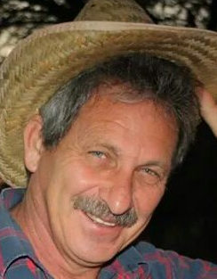
Marieta Bortoli Marilett Jenkins Hennie Venter

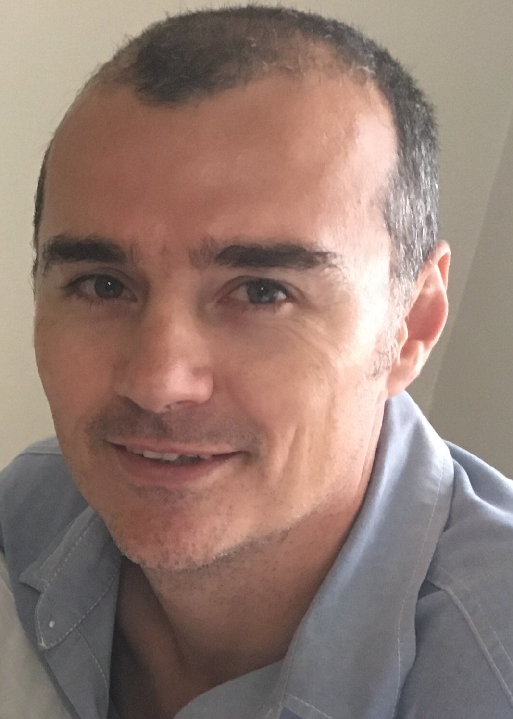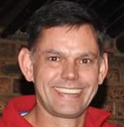
De Wet de Beer André Breytenbach Marix Venter

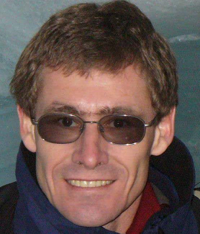
Fred Harding Suzette van Staden Gustav Brink (Ex-officio)

